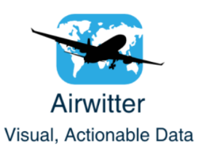

# Airwitter: Investor Documentation

## Introduction

Airwitter is a social media monitoring company which aims to assist airlines by monitoring real-time twitter data sentiment. The unique feature of Airwitter’s visualisation dashboard is that it will allow all employees, including those without a background in statistics, to take relevant actions based on our sentiment analysis.

## Company Structure

Airwitter is divided into two distinct branches:

* Branch 1: This branch focuses entirely on the visualisation of twitter data sentiment. The visualisations outlined below are developed by this branch.
* Branch 2: This branch focuses on the quantitative modelling of twitter data. Pure sentiment analysis using natural language text processing will be the primary function of this branch. Accurate sentiment labelling is crucial for social media monitoring; therefore, this round of funding intends to raise capital to develop this branch of Airwitter.

## Visualisation Tools

In order to demonstrate Airwitter’s capabilities, a labelled twitter dataset was sourced containing sentiment analysis for tweets on US airlines. In the future, this sentiment analysis will be carried out by the team in Branch 2. Outlined in this section is a number of visualisations that Airwitter offer as part of our service. Our visualisation team is well equipped to develop additional visualisations as required by the client.

The Dashboard

Airwitter’s client facing Dashboard is the hub of our data analytics package.

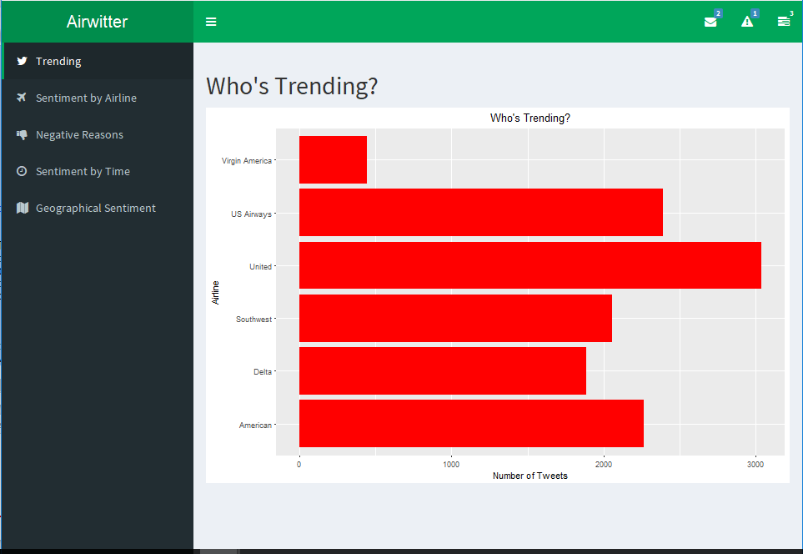

Figure 1:Dashboard

The dashboard header features the company name in the top left corner as well as a series of dropdown panels on the right which can act as a useful resource for employees to display their messages, notifications and task progress bars.

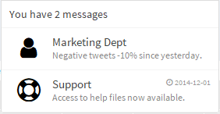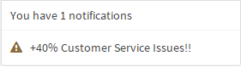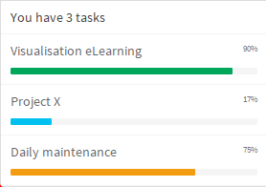

Figure 2: Dashboard Dropdowns

The dashboard sidebar also contains tabs that will direct users to the various visualisations available.

### Visualisations

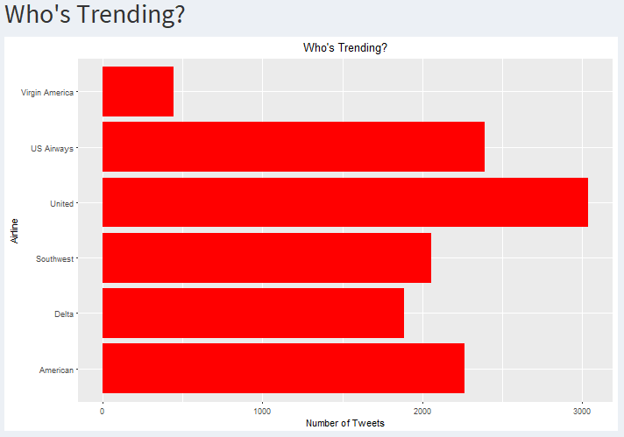

Figure 3: Who's Trending?

Figure 3 acts as a quick comparison tool to see which airlines are experiencing a high volume of tweets over a given time frame. A strong social media presence is vital for all businesses today; however, it is even more important in an industry that offers such wide a variety of choice to the consumer as is the case in the airline industry.

However, Figure 4 outlines that although you may be experiencing a high volume of tweets, it is unlikely that the majority of these tweets will be positive. It is extremely valuable to be aware of the proportion of positive, negative and neutral tweets about your airline. Therefore, the ‘Sentiment by Airline’ graphic will highlight the overarching sentiment for each airline.

It is worth noting that Twitter is a platform renowned for being a place to vent frustrations. The nature of air travel dictates that it is unlikely for a Twitter user to mention their airline after a smooth, routine flight. Therefore, a high proportion of negative sentiment is not surprising. It is more important to focus on the proportion of negative tweets for your airline in comparison to the others.

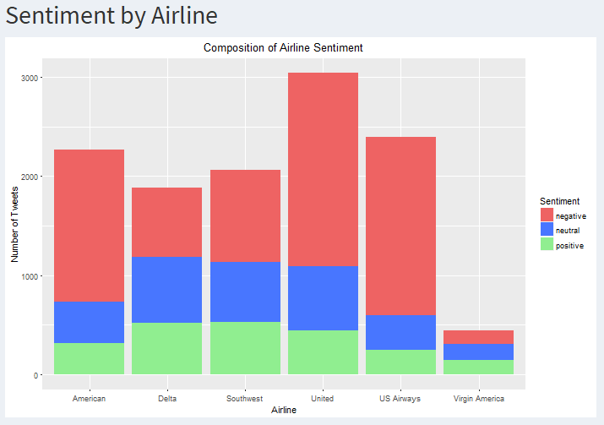

Figure 4: Sentiment by Airline

The sentiment analysis carried out by Branch 2 will be able to determine the reason for negative sentiments. This can be extremely useful as it will allow our clients to identify points in their service that are falling below the expectations of their customers. Figure 5 identifies “Customer Service Issue” as the consistent leader for the cause of negative tweets. This will allow employees at our partnered airlines to take action to improve this part of their business offering. This visualisation has been generated using nine consecutive days along the x-axis however can be modified to display a series of hours, days or months depending on the objective.

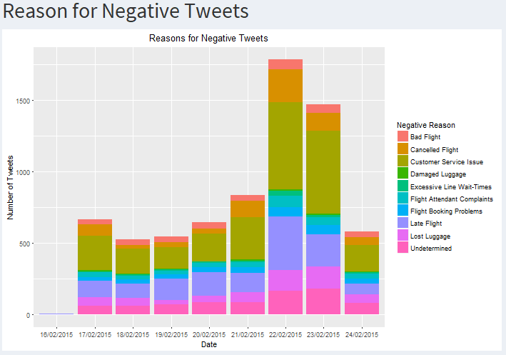

Figure 5:Reasons for Negative Tweet

How users interact with social media tends to vary over the course of the day. Airwitter believe that airlines may benefit greatly from having a social media strategy divided into three “Time Periods” (Morning 04:00-12:00, Evening 12:00-20:00, Night 20:00-04:00). For example, our clients may discover that their users are more likely to tweet positively in the morning and can then run a marketing competition asking users to tweet about why they love “Airline X”. Conversely, they can ensure that they are sufficiently staffed to deal with the influx of negative tweets during the Evening period. Responding efficiently to negative tweets may even result in the generation of customers, satisfied that their complaint has been acknowledged, tweeting positively!

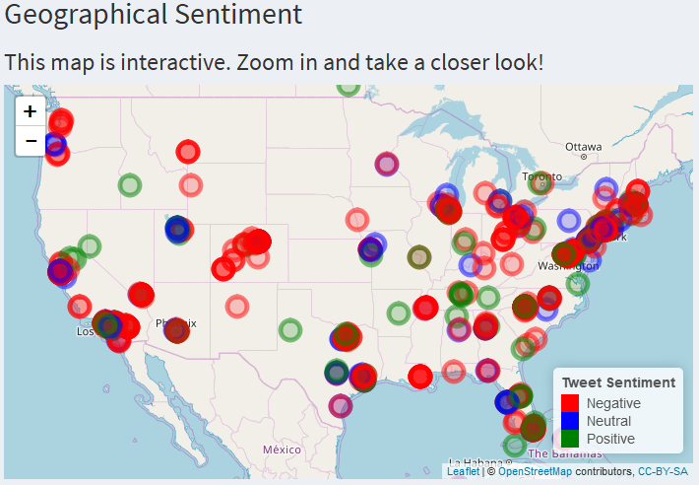

Figure 7: Geographical Sentiment

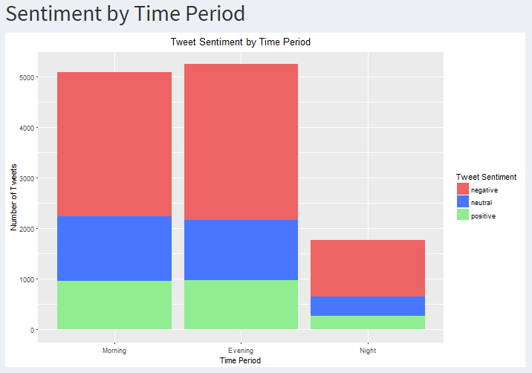

Figure 6: Sentiment by Time Period

Figure 7 uses coordinate data from tweets to map twitter sentiment to its location. This is a very aesthetically-pleasing visualisation that can quickly highlight an area of concern. It is clear from the graphic above that New York is receiving a high volume of Negative tweets. Airlines can then act to address a specific issue or as a more long-term solution, introduce systems that could alleviate the cause of this negativity. As well as that, regions which experience a high volume of Positive tweets can be targeted as areas for airlines to fly to more often as users in these regions appear to be pleased with their service.

Given the range of different cultures across Europe, this feature could be of major benefit to European airlines as they can easily determine which countries are performing well and also those lagging behind.

## Future Developments

As previously mentioned, this round of funding is designed to raise capital to finance the development of Branch 2, the sentiment analysis branch. Airwitter believe that there are a variety of other improvements that this investment could also help to develop:

* As Europe features a multitude of different languages, not only English, as in our sample dataset, Airwitter will make sentiment analysis of all European languages as its number one priority.
* Figure 5 outlined a visualisation demonstrating the reasons for negative tweets. We would like to expand on this basis by analysing the contributing factors for neutral and positive tweets.
* Twitter is just one social medium and although it is our primary target for the first 5 years of our business lifecycle, we believe that our data analysis tools will be easily transferrable to other social media such as Facebook and Instagram.
* Natural Language Processing (NLP) tracks the frequency of words within a set of tweets. Airwitter believe that using this tool to identify positives, such as recurring positive tweets about a specific employee, could highlight those who deserve recognition for consistently doing an excellent job.

## Investment Summary

Airwitter believe that due to the recent increase in the competitive nature of the airline industry, as a result of so many new market entrants, the airlines who take advantage of modern technology will be able to differentiate themselves from the rest. Efficient, comprehensive visualisations make the world of “Big Data” accessible to everyone, regardless of their background. This will enable airlines to take advantage of analytics immediately, with no need to hire an entirely new, statistically proficient workforce.

Should you have any queries regarding the service that Airwitter provide, or would like to meet to discuss this investment opportunity further, please do not hesitate to contact us via email: investment@airwitter.com